How to Upload code to the seeed studio xiao nrf board.

1. Plug the board into a computer
2. Double click the reset button on the board.

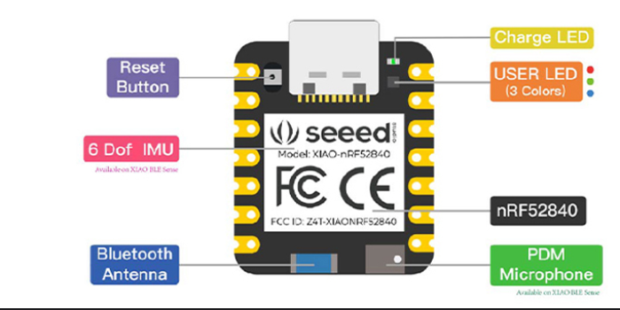

1. If done correctly the board should not turn on and a new device should appear in the file explorer.
2. Drag and drop a **.uf2** file into the device.
3. If successfully done, the device will disappear from the file explorer and the code should start to work.

Wiring Diagram: Seeed Studio Xiao with GPS module

NUM SENSORS

